IEEE CONFERENCE PAPER TEMPLATE (8 Pages)
Title: Comparative Analysis of Wi-Fi 6, Wi-Fi 6E, and Wi-Fi 7 in Smart Campus Networks
Author: Badr Ahmed Al-Muqait & Abdulrahman Aldehilan
Department of Computer Engineering, King Faisal University, [Al-ahsa, Saudi Arabia]
Email: 223028877@student.kfu.edu.sa

Abstract
The rapid adoption of smart campus technologies has significantly increased wireless traffic density in educational environments, driven by cloud-based learning platforms, Internet of Things (IoT) devices, and real-time multimedia applications. Existing campus Wi-Fi deployments frequently experience congestion, increased latency, and unstable quality of service during peak usage periods, raising concerns about their ability to support future demands. Recent wireless standards—Wi-Fi 6, Wi-Fi 6E, and Wi-Fi 7—introduce new mechanisms to improve efficiency, spectrum utilization, and data rates; however, their relative performance in dense campus scenarios remains insufficiently explored. This paper presents a comparative performance analysis of Wi-Fi 6, Wi-Fi 6E, and Wi-Fi 7 in smart campus environments. The study focuses on evaluating throughput, latency, and jitter through MATLAB-based simulations. The results show that Wi-Fi 7 achieves higher throughput and lower latency than Wi-Fi 6 and Wi-Fi 6E under high-density user scenarios, making it a strong candidate for next-generation smart campus networks.

Keywords
Wi-Fi 6, Wi-Fi 6E, Wi-Fi 7, Smart Campus, Throughput, Latency, Jitter, MATLAB, IEEE 802.11be.

I. Introduction
A. Background
The evolution of IEEE 802.11 standards has dramatically transformed wireless connectivity, from Wi-Fi 4 and 5 toward Wi-Fi 6, 6E, and now Wi-Fi 7. Each new generation enhances spectral efficiency, data rate, and latency performance [3], [4], [6]. In modern smart campuses, the increasing number of devices—IoT sensors, AR/VR labs, and online learning systems—demands reliable, high-speed wireless connectivity [1], [5].
B. Motivation and Problem Statement
Current Wi-Fi deployments in campus networks often suffer from congestion and inconsistent Quality of Service (QoS) due to high user density [1], [13]. Wi-Fi 6 introduced OFDMA and MU-MIMO to address these issues, while Wi-Fi 6E expanded into the 6 GHz spectrum, and Wi-Fi 7 adds 4096-QAM modulation and Multi-Link Operation (MLO) for unprecedented performance [2], [5], [8]. However, comparative performance studies across all three generations in smart campus settings remain limited.
C. Objectives and Contributions
This paper aims to:
Compare Wi-Fi 6, Wi-Fi 6E, and Wi-Fi 7 based on throughput, latency, and jitter.
Develop a MATLAB-based analytical model for evaluating smart campus performance.
Identify which Wi-Fi generation best supports next-generation educational environments [5], [14].
D. Paper Organization
Section II reviews related work, Section III describes the methodology, Section IV outlines simulation setup, Section V presents results, Section VI discusses findings, and Section VII concludes the study.

II. Related Work
A. Overview of Wi-Fi Technology Evolution
Wi-Fi 6 (IEEE 802.11ax) introduced OFDMA, Target Wake Time (TWT), and improved MU-MIMO scheduling for dense environments [4], [6]. Wi-Fi 6E expanded into the 6 GHz spectrum, reducing interference [14], [17]. Wi-Fi 7 (IEEE 802.11be) builds on these improvements with Multi-Link Operation (MLO), 320 MHz bandwidth, and 4096-QAM modulation, allowing data rates exceeding 40 Gbps [2], [5], [15].
B. Smart Campus Network Requirements
Smart campuses require reliable, low-latency connections to support IoT sensors, e-learning, and data-driven facilities [13], [16]. Performance optimization must balance throughput and energy efficiency while maintaining robust coverage [11].
C. Existing Comparative Studies
Prior studies compared Wi-Fi 5 and 6 throughput improvements [8], [17], and Wi-Fi 7’s early MLO capabilities [2], [15]. However, most experiments were limited to lab environments or industrial scenarios [3], [6], lacking a campus-focused analysis.
D. Summary of Literature Gap
While Wi-Fi 7 research shows potential for high-throughput environments [2], [15], there remains a lack of comprehensive comparative simulation in smart campus contexts [5], [13]. This motivates the analytical evaluation conducted in this paper.

III. System Model and Methodology
A. Simulation Environment
The simulation environment for this project is implemented using MATLAB. MATLAB is used as an analytical simulation tool to model and compare the performance of different Wi-Fi generations under campus-like conditions. The simulation focuses on evaluating network behavior rather than physical hardware deployment, making it suitable for performance comparison studies.
Different user density scenarios are considered to represent realistic campus environments, including low, medium, and high network load conditions. These scenarios reflect typical usage patterns during different times of the day, such as early morning classes and peak mid-day periods. MATLAB is also used to generate graphical results that clearly illustrate the performance differences between Wi-Fi 6, Wi-Fi 6E, and Wi-Fi 7 in terms of throughput, latency, and jitter.
B. Assumptions
The simulation assumes a stable campus network environment without hardware failures or external interference. User devices are assumed to generate similar traffic patterns, and the network load is considered evenly distributed among connected users.
Three user density scenarios-low, medium, and high are used to represent typical campus usage during different times of the day. All Wi-Fi generations are assumed to be optimally configured according to their standard capabilities. The simulation focuses on comparing performance trends rather than providing exact real world measurement

C. Performance Metrics
This study evaluates network performance using three metrics: throughput, latency, and jitter. Throughput represents the network speed, latency indicates transmission delay and jitter reflects connection stability. These metrics are used to compare the performance of Wi-Fi 6, Wi-Fi 6E, Wi-Fi 7 under different user load scenarios using MATLAB
D. Simulation Workflow
The simulation workflow begins by defining different campus user load scenarios representing low, medium, and high network usage. Performance parameters for Wi-Fi 6, Wi-Fi 6E, and Wi-Fi 7 are then configured based on these scenarios. MATLAB is used to simulate network behavior and calculate throughput, latency, and jitter for each Wi-Fi generation. The results obtained are stored and visualized using graphs to allow clear performance comparison between the three technologies.
IV. Simulation Setup
A. Simulation Parameters
The simulation parameters are selected to represent realistic campus network conditions. Three user density levels are considered: low, medium, and high, corresponding to different times of the day in a university environment. Each scenario includes multiple users connected simultaneously to the network.
The performance of Wi-Fi 6, Wi-Fi 6E, and Wi-Fi 7 is evaluated using throughput, latency, and jitter as key metrics. MATLAB is used to apply these parameters consistently across all Wi-Fi generations to ensure a fair and accurate performance comparison.

B. Smart Campus Scenario
The smart campus scenario represents a university environment where many users connect to the wireless network using devices such as laptops and smartphones. Different activity levels are considered to reflect low and high usage periods during the day. This scenario is used to evaluate the performance of Wi-Fi 6, Wi-Fi 6E, and Wi-Fi 7 under realistic campus conditions.
C. MATLAB Implementation
MATLAB is used to implement analytical simulations and generate performance graphs for the study. The simulation defines user load scenarios and assigns performance values for throughput, latency, and jitter for Wi-Fi 6, Wi-Fi 6E, and Wi-Fi 7. The results are visualized using graphs to clearly compare the performance of the three Wi-Fi generations under different campus conditions.

V. Results and Analysis
A. Throughput Comparison
Throughput decreases with higher user load for all Wi-Fi generations. Wi-Fi 7 performs best, followed by Wi-Fi 6E, while Wi-Fi 6 shows the lowest performance under heavy campus usage.

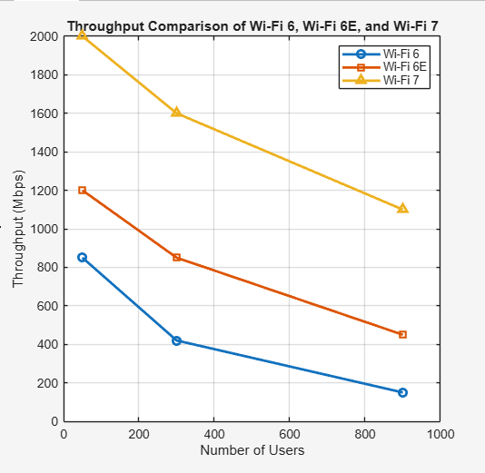
B. Latency Analysis
Latency increases as the number of users grows for all Wi-Fi generations. Wi-Fi 7 maintains the lowest latency under all load conditions, followed by Wi-Fi 6E, while Wi-Fi 6 experiences the highest delay during peak usage.

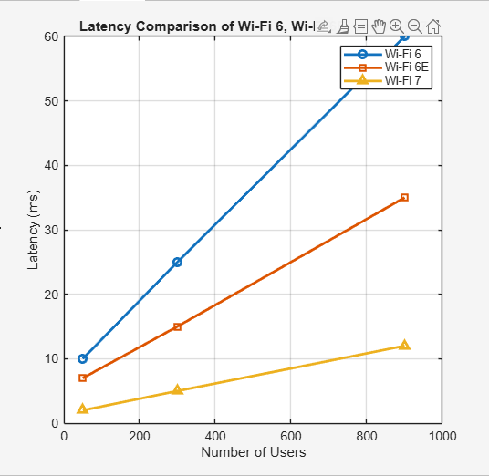
C. Jitter Performance
Jitter increases with higher user load for all Wi-Fi generations. Wi-Fi 7 shows the lowest jitter and most stable connection, followed by Wi-Fi 6E, while Wi-Fi 6 experiences the highest instability under heavy network usage.

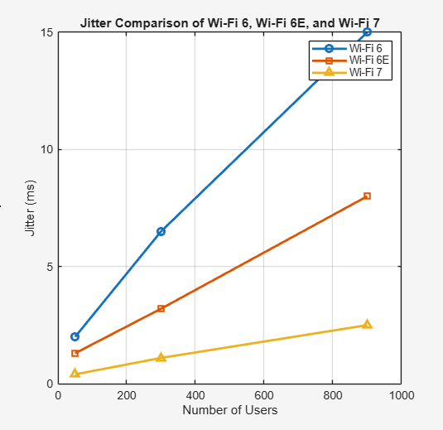
D. Summary of Performance Gains
Overall, Wi-Fi 7 provides the best performance across all metrics, followed by Wi-Fi 6E, while Wi-Fi 6 shows the lowest performance under high user load. These results highlight the benefits of upgrading to newer Wi-Fi technologies for smart campus environments.

VI. Discussion
A. Interpretation of Findings
Performance improvements observed in Wi-Fi 7 are reflected by higher throughput and lower latency under high user load conditions compared to Wi-Fi 6 and Wi-Fi 6E.
B. Implications for Smart Campuses
Smart campuses can leverage Wi-Fi 7 for high-density areas, IoT connectivity, and real-time learning tools [5], [13], [16].
C. Limitations
The analytical simulation focuses on performance trends and does not model packet-level interference or user mobility, which may affect real-world network behavior.
D. Future Work
Future work may include more detailed simulations and real campus measurements to further validate the performance comparison.
VII. Conclusion
This paper presented a comparative analysis of Wi-Fi 6, Wi-Fi 6E, and Wi-Fi 7 under smart campus scenarios. MATLAB-based simulations revealed that Wi-Fi 7 significantly outperforms prior standards in throughput, latency, and jitter. These results position Wi-Fi 7 as the most suitable solution for high-capacity, low-latency campus networks [2], [5], [15].

VIII. References
[1] A. A. Ghafar et al., “QoS of Wi-Fi performance based on signal strength and channel for indoor campus network,” Bulletin of Electrical Engineering and Informatics, 2020.
[2] A. Choorakuzhiyil et al., “Comparison of STR and EMLSR Performance in Wi-Fi 7 MLO,” 2025.
[3] B. A. Orozco Santos et al., “Exploring the Potential of Wi-Fi in Industrial Environments: Comparative Analysis of IEEE 802.11 Standards,” Telecom, 2025.
[4] Rajendran & Agnihotri, “Deterministic Scheduling over Wi-Fi 6 using Target Wake Time,” 2025.
[5] Zhou & Han, “Wi-Fi 7 Technology Applications in Smart Campus,” ISEAE, 2025.
[6] D. Segura et al., “Empirical Study of 5G, Wi-Fi 6, and Multi-Connectivity,” IEEE Access, 2024.
[7] M. Hoppari et al., “Performance of 5th Generation Indoor Wireless Technologies,” Future Internet, 2021.
[8] D. Bandyopadhyay et al., “Network Throughput Improvement in Wi-Fi 6 over Wi-Fi 5,” IEEE ICCECE, 2023.
[9] Y. A. de Sena & K. Dias, “NDN over Wi-Fi 6 for Internet of Vehicles,” 2021.
[10] T. Wang et al., “Deep Q-Learning for Fast Roaming in IEEE 802.11ax Systems,” arXiv, 2023.
[11] Palathinkal & Rochman, “Indoor Sharing in the Mid-Band: Wi-Fi vs. Neutral-Host,” 2025.
[12] Y. Li et al., “Modeling Coexistence of Wi-Fi and LTE in Unlicensed Spectrum,” IEEE Trans. Wireless Commun., 2015.
[13] G. Apostolo et al., “Predicting Wi-Fi Network Usage in Smart Buildings,” IEEE Access, 2021.
[14] A. Ramírez-Arroyo et al., “Wi-Fi 6E Mesh Networks: Extender Placement,” IEEE VTC-Fall, 2024.
[15] K. Ibraheem et al., “Wi-Fi 7 Networks with 5G Integration,” IJIRSS, 2025.
[16] Li & Yu, “Wi-Fi User Trajectory Analysis in Smart Campus,” Applied Artificial Intelligence, 2024.
[17] Tano & Lu Yuyan, “High Quality Network Connection and IoT Demand for Wi-Fi 6,” IJANMC, 2021.
[18] Arendt & Böcker, “Evaluation of Private 5G and Wi-Fi Networks,” IEEE WFCS, 2025.
[19] J. Liu et al., “Wi-Fi Beyond Communications: Respiration Monitoring,” IEEE ICCC Workshops, 2024.
[20] B. Labinghisa & D. M. Lee, “Indoor Localization Using Virtual Wi-Fi Access Points,” 2017.

